**Skewness and Kurtosis Analysis and code conversion from R to Python**

**(1) Skewness and Kurtosis for Campuses:**

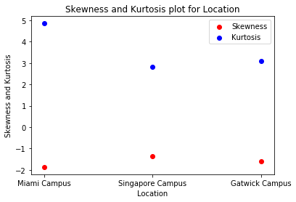

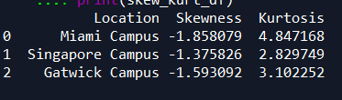

**(2) Skewness and Kurtosis for Miami campuses :**

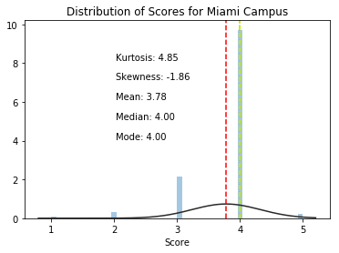

Based on the mean, median, mode, skewness, and kurtosis provided, here is a possible analysis:

* Mean: The mean of the data is 3.78, which is lower than the median (4.0) and the mode (4). This suggests that the data may be positively skewed, meaning that there are some values that are pulling the mean down relative to the median and mode.
* Median: The median of the data is 4.0, which is higher than the mean (3.78). This is consistent with the positive skewness and suggests that the majority of the values in the data are higher than the mean.
* Mode: The mode of the data is 4, which is higher than the mean (3.78) and the median (4.0). This is also consistent with the positive skewness and suggests that the most frequently occurring value in the data is higher than the mean and median.
* Skewness: The skewness of the data is -1.86, which is negative. This indicates that the data is positively skewed, meaning that the tail of the distribution extends to the right (towards higher values) and that there are some relatively large values that are pulling the mean down.
* Kurtosis: The kurtosis of the data is 4.85, which is positive. This indicates that the distribution is more peaked than a normal distribution and has heavier tails, meaning that there are more values that are further away from the mean.
* Skewness: The skewness value of -1.86 suggests that the data is positively skewed, meaning that the tail of the distribution extends to the right, or towards higher values. A skewness value of 0 would indicate a perfectly symmetrical distribution, and a skewness value greater than 0 would indicate a positive skew. Positive skewness is often seen in datasets where there are a few large values that are pulling the mean up relative to the median and mode. In such cases, the mean is often a less representative measure of central tendency than the median or mode.
* Kurtosis: The kurtosis value of 4.85 suggests that the data is more peaked than a normal distribution, and has heavier tails. In other words, there are more values in the data that are further away from the mean than would be expected in a normal distribution. A kurtosis value of 3 indicates a normal distribution, while a kurtosis value greater than 3 indicates a distribution with heavier tails. A positive kurtosis is often seen in distributions where there are a few large values that are driving the kurtosis higher. In such cases, the standard deviation may not provide a complete picture of the spread of the data and other measures such as the range, interquartile range, or percentiles may be useful.

**(3) Skewness and Kurtosis for Singapore campuses:**

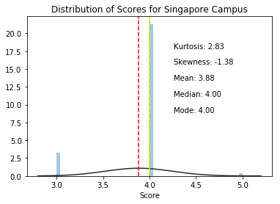

Based on the mean, median, mode, skewness, and kurtosis provided, here is a possible analysis:

* Mean: The mean of the data is 3.88, which is slightly lower than the median (4.0) and the mode (4). This suggests that the data may be positively skewed, meaning that there are some values that are pulling the mean down relative to the median and mode.
* Median: The median of the data is 4.0, which is higher than the mean (3.88). This is consistent with the positive skewness and suggests that the majority of the values in the data are higher than the mean.
* Mode: The mode of the data is 4, which is higher than the mean (3.88) and the median (4.0). This is also consistent with the positive skewness and suggests that the most frequently occurring value in the data is higher than the mean and median.
* Skewness: The skewness of the data is -1.38, which is negative. This indicates that the data is positively skewed, meaning that the tail of the distribution extends to the right (towards higher values) and that there are some relatively large values that are pulling the mean down.
* Kurtosis: The kurtosis of the data is 2.83, which is positive but lower than 3. This indicates that the distribution is somewhat more peaked than a normal distribution but not as much as a distribution with a kurtosis greater than 3.

**(4) Skewness and Kurtosis for Gatwick campuses:**

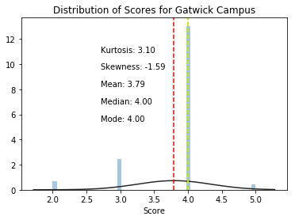

Here's an analysis based on the mean, median, mode, skewness, and kurtosis provided:

* Mean: The mean of the data is 3.79, which is lower than the median (4.0) and the mode (4). This suggests that the data is positively skewed, meaning that there are some values that are pulling the mean down relative to the median and mode.
* Median: The median of the data is 4.0, which is higher than the mean (3.79). This is consistent with the positive skewness and suggests that the majority of the values in the data are higher than the mean.
* Mode: The mode of the data is 4, which is higher than the mean (3.79) and the median (4.0). This is also consistent with the positive skewness and suggests that the most frequently occurring value in the data is higher than the mean and median.
* Skewness: The skewness of the data is -1.59, which is negative. This indicates that the data is positively skewed, meaning that the tail of the distribution extends to the right (towards higher values) and that there are some relatively large values that are pulling the mean down.
* Kurtosis: The kurtosis of the data is 3.10, which is positive and slightly higher than 3. This indicates that the distribution is more peaked than a normal distribution but not as much as a distribution with a kurtosis greater than 3.